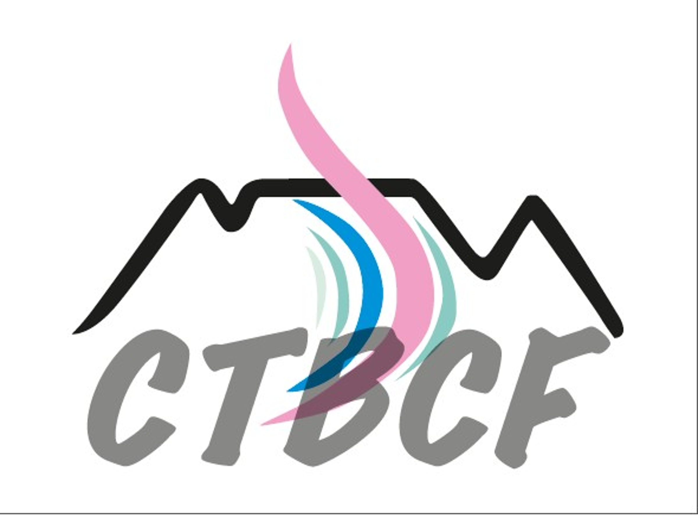
SAVE THE DATE | MONDAY, 2 NOVEMBER 2026
CAPE TOWN BREAST CANCER FORUM
Online meeting and CTBCF Committee Planning Meeting
ONCOPLASTIC SURGERY: ONE TEAM, ONE GOAL – BETTER OUTCOMES
• CPD Accredited
PROGRAMME
Session | Format / lead | Time
Welcome and introduction | Dr Britta Dedekind | 6.30–6.45 pm
Case presentation 1 | MDT style | 6.45–7.15 pm
Case presentation 2 | MDT style | 7.15–7.45 pm
Questions and discussion | All | 7.45–8.00 pm
Meeting close by the Chairperson of CTBCF | Dr Liana Roodt | 8.00 pm
CTBCF planning meeting: Dates and Topics | Planning committee | 8.15 pm onwards

PRESENTERS — TEAM APPROACH
• Dr Britta Dedekind, Breast Surgeon, CBMH | • Ms Gabby Frantzekakis, Clinical Associate, Cape Oncology
• Dr Tamiya Nair, Radiologist, Morton & Partners | • Dr Chris Price, Plastic Surgeon, CBMH
• Dr Diana Jaravaz, Pathologist, Pathcare | • Dr Nicole Morse, Pathologist, Lancet

RSVP
Name: __________________________________________ MP / Practice: __________________________________
Specialty: _______________________________________ Email address: _________________________________
Please inform me of future meetings: ☐ Yes ☐ No
For enquiries, please contact Liandi Nieuwoudt: 082 555 8993
liandi@equitypharma.co.za
Supported by Equity Oncology

